
DATA STRUCTURES AND ALGORITHMS
LAB REPORT
Submitted by
Name | PINNABATHINA DEEKSHITHA
Roll no | AV.SC.U4CSE25143
Year/Sem/Section | 1stYear/Sem-2/CSE-B
Credits | 03
Submitted to
Name | Dr. RAJ KUMAR BATCHU
Designation | Asst. Professor (SI. Grade)
Department | School Of Computing

INDEX
S.no: | Program | Pg No: | Remarks
1. | WEEK 1:  1(A): A rocket launch system displays a countdown before launch. Instead of using loop, implement the countdown using recursion. Write a recursive python program to display a countdown from n to 1 followed by launch.  1(B): Banks calculate the growth of the investment using compound interest. The formula requires calculating powers, which can be implemented recursively. Write a recursive program to calculate P^{n} (power, where P=principal for factor growth, n=number of years)  1(C): An HR department stores employee id’ s in a list. Develop a recursive program to search given employee ID. Write a recursive function to search for employee ID in list.  1(D): In logistics company, the number of possible ways to arrange n different parcels are calculated using factorial formula(n!). Develop a recursive program to calculate the factorial of the given number.  1(E): Write a recursive python program to print the first n terms of Fibonacci series. | 06-08
2. | WEEK2:  2(A): Write a python program to implement linear search.  2(B): Write a python program to implement binary search with and without sorted array as an input. | 08-27
3. | WEEK3:  3(A): Write a program to implement bubble sort, where the elements are taken from the user.  3(B): Write a program to implement insertion sort, where the elements are taken from the user.  3(C): Write a program to implement selection sort, where the elements are taken from the user. | 28-43

AIM:1A) A rocket launch system displays a countdown before launch. Instead of using loop, implement the countdown using recursion. Write a recursive python program to display a countdown from n to 1 followed by launch.
CODE: 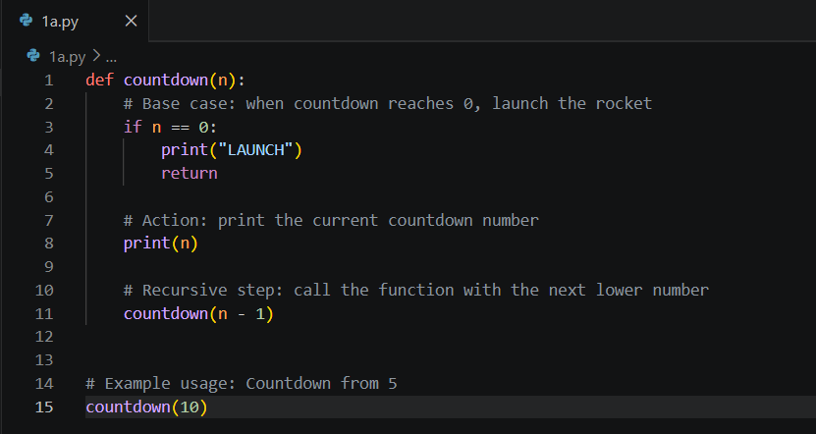
OUTPUT: 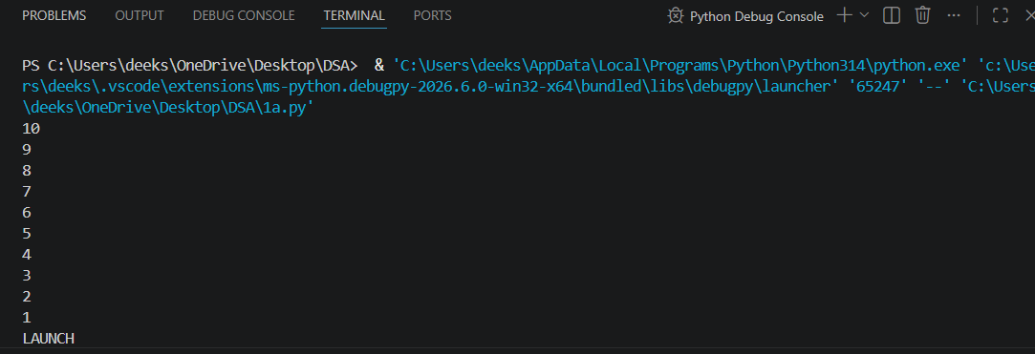

ERROR TABLE:
Error | Reason |  | Solution
TypeError | The argument is not a number. |  | Pass an integer value.
Infinite recursion | The base case (n == 0) is removed or written incorrectly. |  | Keep the base case unchanged.
Logical error | A negative number is passed. |  | Check that n is greater than or equal to 0 before calling the function.

AIM:1B) Banks calculate the growth of the investment using compound interest. The formula requires calculating powers, which can be implemented recursively. Write a recursive program to calculate P^{n} (power, where P=principal for factor growth, n=number of years)
CODE: 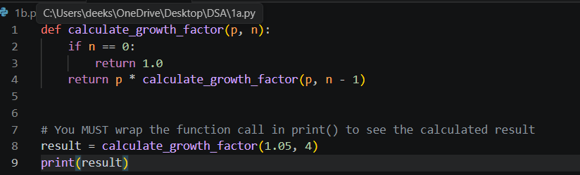
OUTPUT: 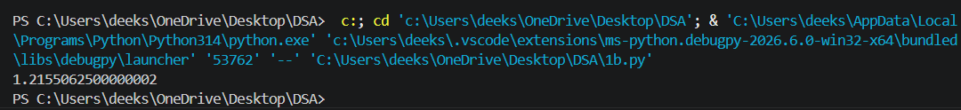
ERROR TABLE:
ERROR | REASON | SOLUTION
Type error | Used equal operator. | Used assignment operator.
Indentation error | Space between words. | Removed space.

AIM: 1C) An HR department stores employee id’ s in a list. Develop a recursive program to search given employee ID. Write a recursive function to search for employee ID in list.
CODE: 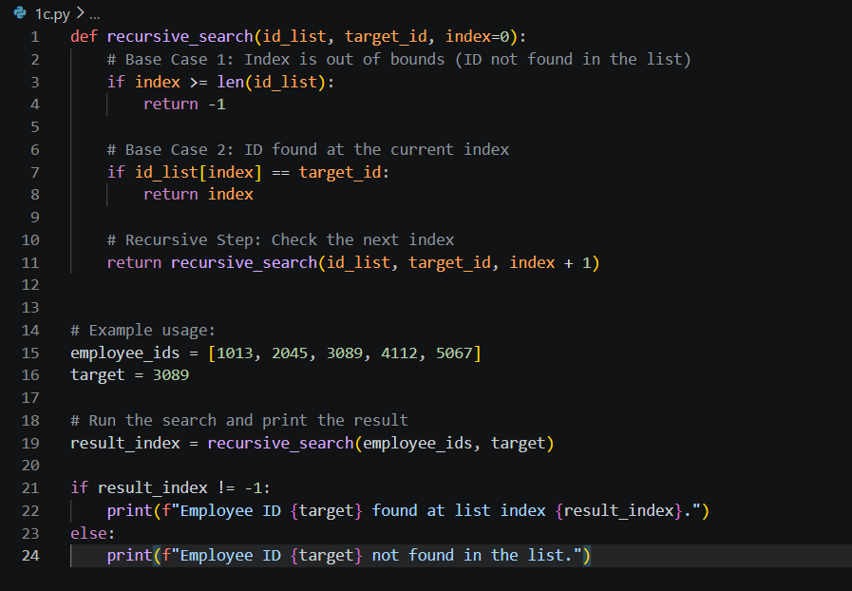
OUTPUT: 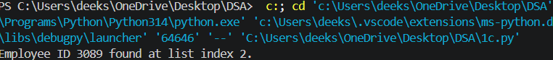
ERROR TABLE:
Error | Reason | Solution
Syntax error | Incorrect use of symbols, brackets, or keywords. | Check the syntax carefully.
Logical error | The program runs, but the output is incorrect | Trace the program step by step and correct the logic
Type error | An operation is performed on incompatible data types
  Use the correct data types
AIM:1D) In logistics company, the number of possible ways to arrange n different parcels are calculated using factorial formula(n!). Develop a recursive program to calculate the factorial of the given number.
CODE: 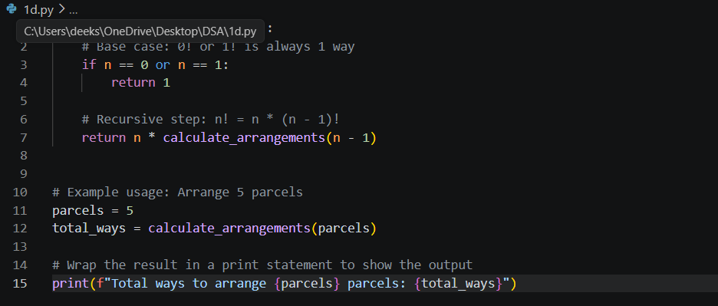
OUTPUT: 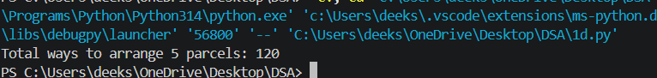
ERROR TABLE:
TYPE OF ERROR | REASON | SOLUTION
 | Incorrect alignment of statements | Use proper indentation
  Indentation error
Syntax error | Missing or incorrect symbols, brackets, or keywords
  Check the program syntax
Missing base case | No stopping condition is provided in a recursive factorial program | Add a base case such as if n == 0
Incorrect return statement | The function does not return the factorial value correctly
  Use the correct return statement
AIM: 1E) Write a recursive python program to print the first n terms of Fibonacci series.
CODE: 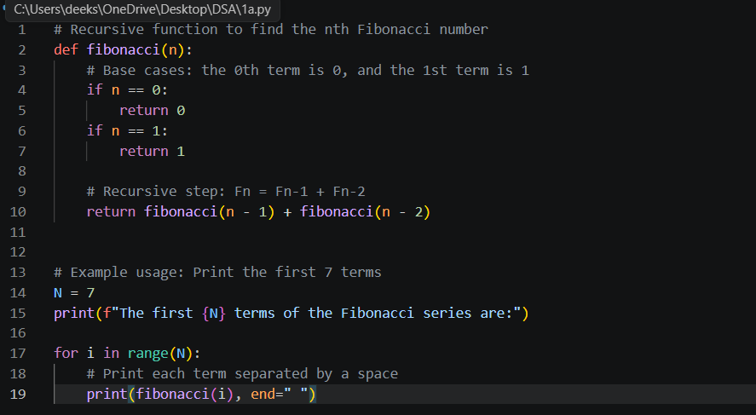OUTPUT:
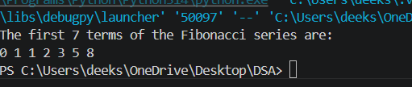
ERROR TABLE:
TYPE OF ERROR | REASON | SOLUTION
 | Incorrect alignment of statements | Use proper indentation
  Indentation error
Syntax error | Missing or incorrect symbols, brackets, or keywords
  Check the program syntax
Missing base case | No stopping condition is provided in a recursive factorial program | Add a base case such as if n <= 1

WEEK2:
AIM:2A) Write a python program to implement linear search with and without sorted array as an input.
CODE: 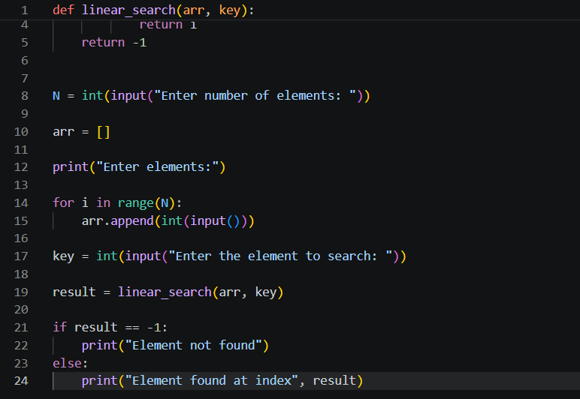
OUTPUT: 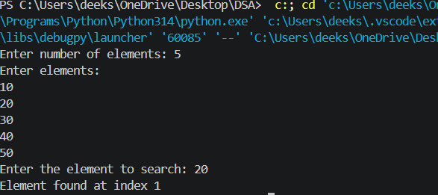

ERROR TABLE:
TYPE OF ERROR | REASON | SOLUTION
 | Incorrect alignment of statements | Use proper indentation
  Indentation error
Syntax error | Missing or incorrect symbols, brackets, or keywords
  Check the program syntax
Incorrect loop range | The loop does not traverse all elements of the array | Use the correct range to access every element
Index out of range | The program tries to access an invalid index
  Use the correct return statement

AIM:2B) Write a python program to implement binary search with and without sorted array as an input.
CODE: 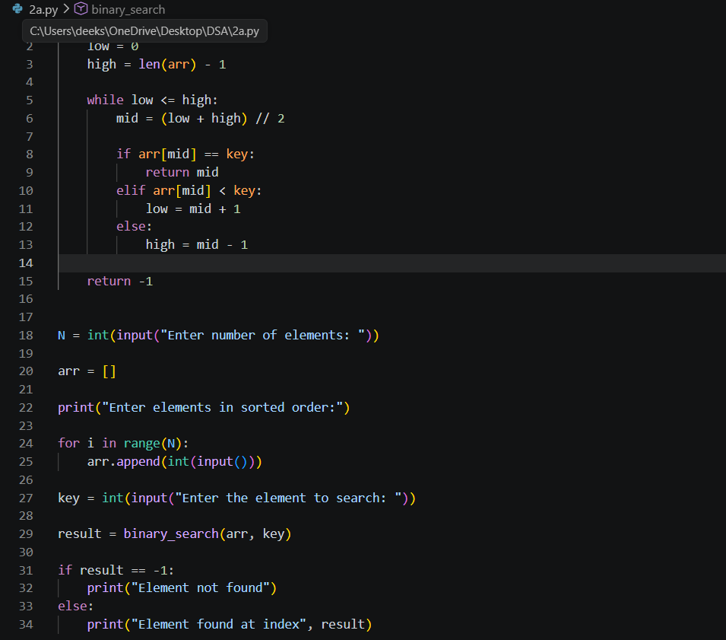
OUTPUT: 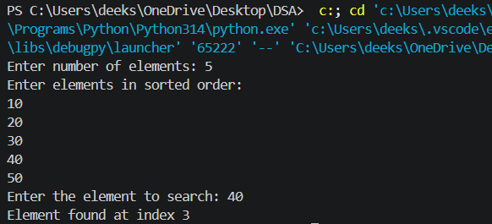
ERROR TABLE:
TYPE OF ERROR | REASON | SOLUTION
 | Incorrect alignment of statements | Use proper indentation
  Indentation error
Syntax error | Missing or incorrect symbols, brackets, or keywords
  Check the program syntax
Unsorted array | Binary search is applied to an unsorted array | Sort the array before performing the search
Incorrect middle index | The middle element is calculated incorrectly
  Use the correct formula: mid = (low + high) // 2

WEEK3:
AIM:3A) Write a program to implement bubble sort, where the elements are taken from the user.
CODE: 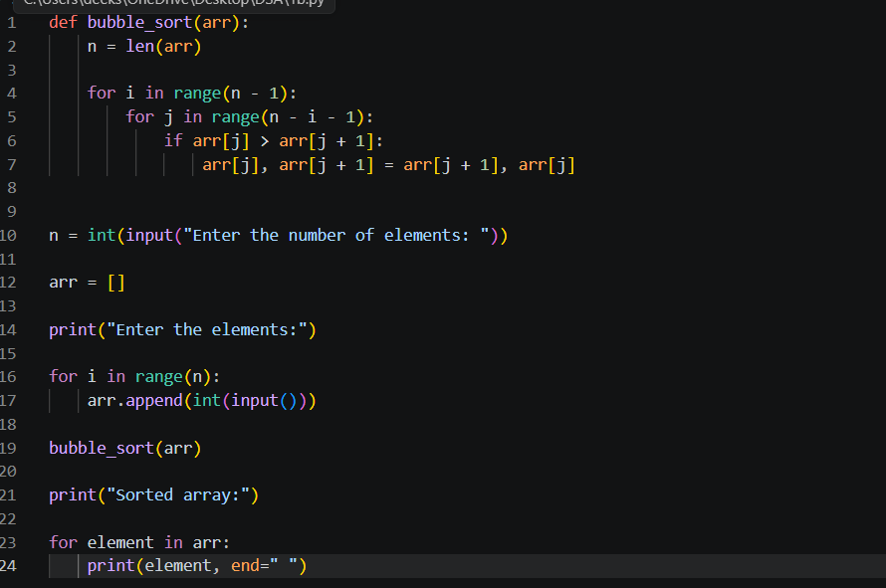
OUTPUT: 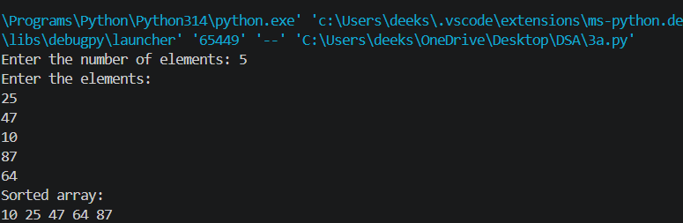

ERROR TABLE:
TYPE OF ERROR | REASON | SOLUTION
 | Incorrect alignment of statements | Use proper indentation
  Indentation error
Syntax error | Missing or incorrect symbols, brackets, or keywords
  Check the program syntax
Incorrect loop range | The loop does not traverse all elements of the array | Use the correct range to access every element
Incorrect swapping | The elements are not exchanged correctly
  Use the correct swapping statement

AIM:3B) Write a program to implement insertion sort, where the elements are taken from the user.
CODE: 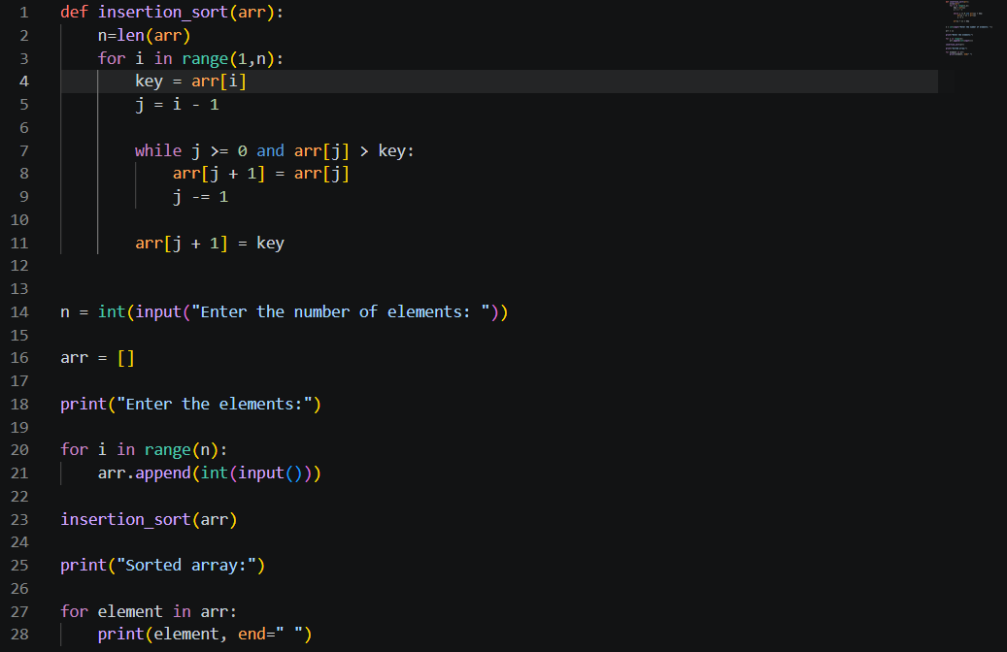
OUTPUT: 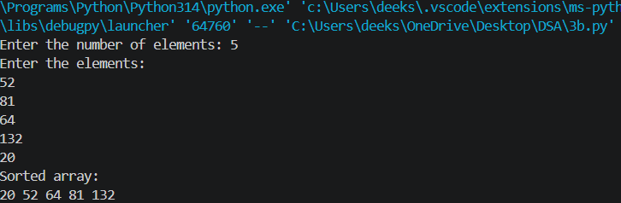

ERROR TABLE:
TYPE OF ERROR | REASON | SOLUTION
 | Incorrect alignment of statements | Use proper indentation
  Indentation error
Syntax error | Missing or incorrect symbols, brackets, or keywords
  Check the program syntax
Incorrect loop range | The loop does not traverse all elements of the array | Use the correct range to access every element
Incorrect insertion or shifting | The elements are not shifted correctly
  Use the correct shifting statement

AIM: 3C)Write a program to implement selection sort, where the elements are taken from the user.
CODE: 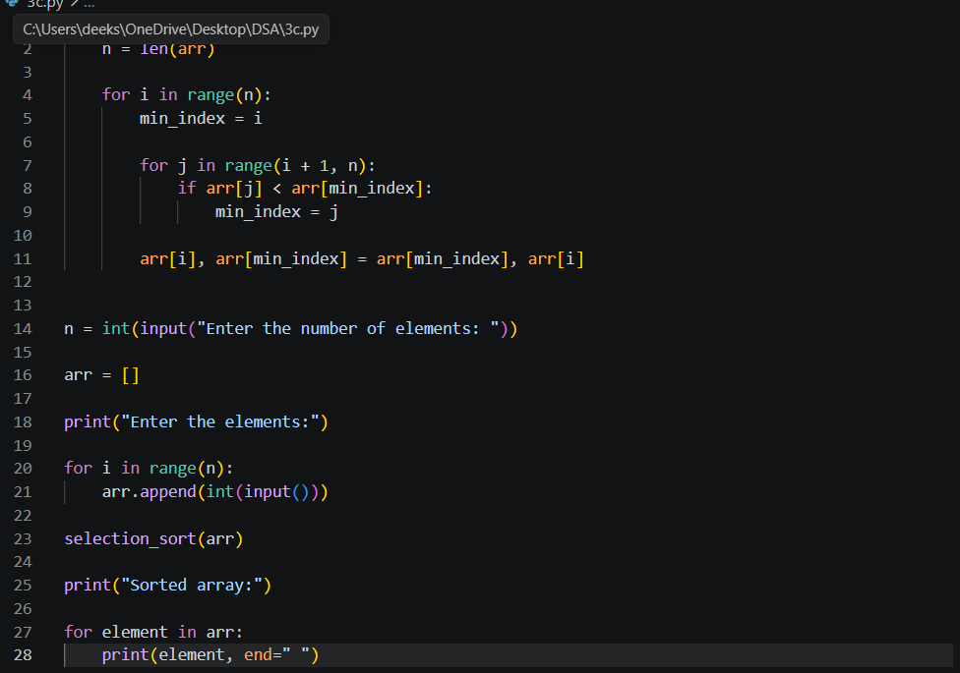
OUTPUT: 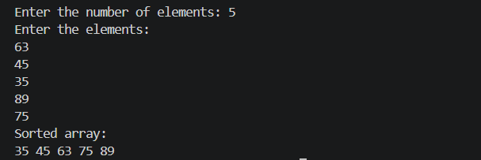

ERROR TABLE:
TYPE OF ERROR | REASON | SOLUTION
 | Incorrect alignment of statements | Use proper indentation
  Indentation error
Syntax error | Missing or incorrect symbols, brackets, or keywords
  Check the program syntax
Incorrect loop range | The loop does not compare all elements of the array | Use the correct range to access every element
Incorrect minimum element selection | The smallest element is not identified correctly
  Update the minimum index correctly before swapping.

